Metropolitan Museum Debuts Roof Garden Commission: Dan Graham with Günther Vogt
April 29, 2014 5:49 AM
Who needs a plain old terrace when you can have a Hedge Two-Way Mirror Walkabout? Nancy Lazarus heads to the roof of the Met to reflect on the matter.
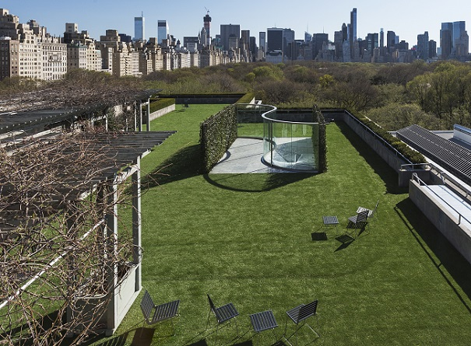
(Photos: Hyla Skopitz, The Photograph Studio, The Metropolitan Museum of Art)
As the Metropolitan Museum of Art prepares to roll out the red carpet for its Costume Institute gala, it has rolled out a green carpet of grass turf for its annual roof garden exhibit: Two-Way Hedge Labyrinth Walkabout, a collaboration between American artist Dan Graham and Swiss landscape architect Günther Vogt.

“I designed the changing convex and concave pavilion as a funhouse for kids and a photo op for parents,” said Graham at Monday’s press preview. “The work relates to Central Park and to the earlier works in my collection.” Some of his prior projects are on view in a companion exhibit on the museum’s second floor. That multimedia display encompasses photos, architectural models, videos, and a smaller, triangular-shaped glass pavilion with circular cutouts.
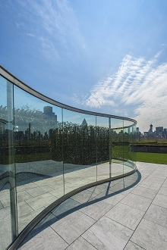The Graham roof garden installation represents a sharp contrast from last year’s Imran Qureshi work, and marks a return to a three-dimensional, sculptural project. Still,Sheena Wagstaff, the Met’s chairman of modern and contemporary art, said the two works share many elements, such as the relationship of the space to history and to its surroundings.
“Dan is preoccupied with issues of urbanism. He creates sculptural environments of mirrors and metal,” said Wagstaff. “They’re called pavilions after 17th and 18th century European formal gardens, but here Dan was distracted by the Met’s roof because it’s leftover space.”
“Graham completely re-imagined a confusing space here and resolved a complex situation in an elegant, new way,” added Ian Alteveer, who organized the roof garden installation with Wagstaff. He said the installation process, which took just under four weeks, was also complicated, involving a team of architects and glass steel fabricators from Belgium and local landscape architects from Brooklyn.

With lots of greenery, soft turf underfoot, and a “go with the flow” ease, the pavilion is likely to be a crowd pleaser. As Graham noted, it’ll be a photographer’s paradise, and the reflective glass will likely serve as a prime backdrop for selfies. Vogt also designed monogrammed chairs, though many visitors may prefer to sit on the grass, picnic-style. “Of all the installations here, few have linked the roof garden and Central Park as seamlessly as this,” said Metropolitan Museum of Art director Thomas Campbell. “Dan Graham treats us to a piece that invites romance, play, and literally, reflection.”

